1. 
2. A diagram of several cylinders

   Description automatically generated with medium confidence  
     
   A diagram of a computer code

   Description automatically generated with medium confidence
3. A diagram of a diagram

   Description automatically generated
4. Let us do this in terminal.
5. A screenshot of a computer

   Description automatically generated
6. Yes, but we can use git cat-file command to see the type of a Git Object.
7. 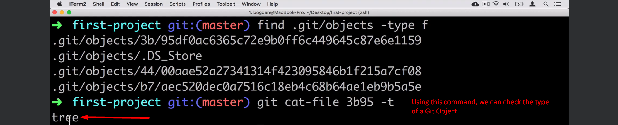
8. Let’s read file from Git Repo and put into staging area.
9. 
10. A diagram of a diagram of a diagram

    Description automatically generated
11. Next Lecture, we will examine the contents of the staging area.